**Why a website is important for business in Nepal**

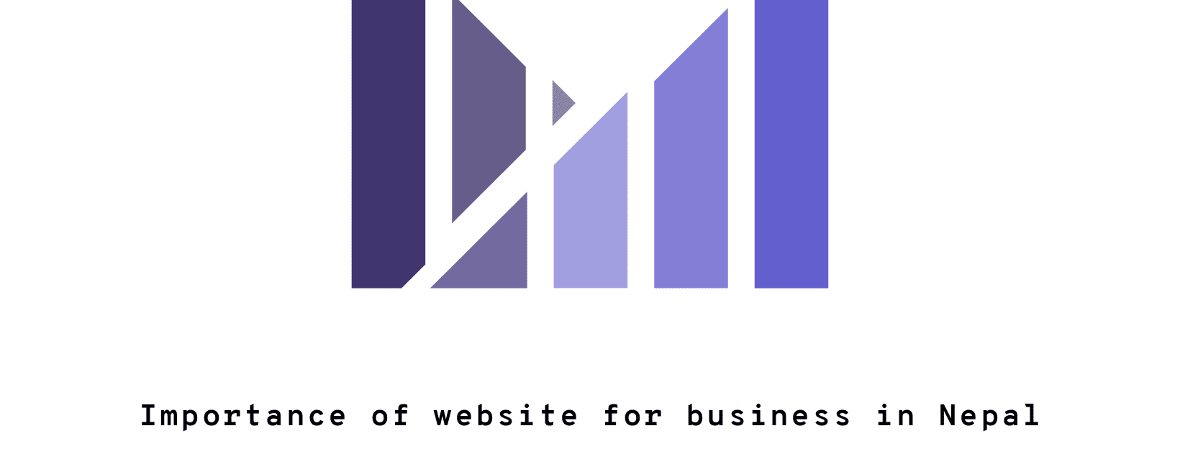

There are over 4.33 billion internet users currently, covering 56 percent of the world’s population. Based on this fact, it is essential for any business to have a website with all the details of their products and services. In this modern era, almost all the companies in developed countries are operating their business through online. Web content is the most convenient way to connect with your customers and track their behavior and launch products or services as per their needs.

When it comes to the Nepali business market, a website is the most effective way to do marketing of a business. Either it is a big corporate house or a small startup; it is obviously the best instrument to inform your potential customer about your business. No matter how much you spent on creating a site, the presence of your business on the internet matters the most.

While talking about the online business in Nepal, there are various types of business which are doing business online and making good earnings. There are various sectors in the Nepali market where many companies have made the website as their primary tool for promoting business. Let’s talk about some sectors in Nepal which need to go online so that they can take it to another level.

**Travel and trekking agencies**

Trekking in Nepal is the best way to experience the natural beauty and diverse culture and website can be primary platform to promote this business. The potential customers of this business are mostly from foreign countries. So, having a website is a huge advantage, not only to show your presence but also to promote business. It is almost impossible to reach those audiences without web content. Doing SEO of your website can be a smart move as this will help to rank your site at the top which will definitely attract more traffic. Your customers can take benefit of booking ticket and tour packages online. This will help in boosting your business and built good reputation among the customers. Actually, it is the cheapest tool to reach those clients and promote tourism in Nepal.

At the same time, digital marketing of your business on social media and Google can be a tricky step to take. More the traffic more chance of business, so it is very important to marketing in many platforms depending on characteristic of your business. There were 2,827,000 active Facebook users in Nepal till January, 2019 which obviously become a go to platform for promoting your business. Advertising on social media will connect you to the international as well as domestic clients. There is a mammoth possibility of getting business because your customers can contact you directly and their queries can be solved online.

**Nepali handicraft business**

There is a huge demand for Nepali handicrafts in the foreign market. Any potential buyer who wants to buy a Nepali handmade product wants to get all the information online and buy from there. It’s not possible for the customer to come to the shop and order the product he needs. So, it has been a compulsion for those entrepreneurs to have a website to promote their products so that it will be convenient for both buyer and seller.

**Education sector**

For the prosperity of any country, education plays a vital role. Children and youths are related to this sector and use social networks and familiar with technology. So, while choosing any institution they first visit the website of that organization and go through the information provided there. That is why an education institute must show its internet presence making a good website for getting business.

**E-commerce business**

E-commerce is also known as electronic commerce or internet commerce where buyers and sellers are connected through the internet. It is impossible to start this business without a website. Online presence is the foundation of this business. So, in this business, there must be a quality site that can attract customers.

**Startup business**

Most of the startups have a limited budget but have a new theme, so marketing is essential. A website can be the cheapest way to do promoting for any startup business. A normal website for a startup costs ssRs1000 but if you want to make quality one there is no limit of price.

**Manpower company/HR Company**

Manpower/HR Company provides a manpower recruitment facility to different companies located outside Nepal. A website can make human enrollment service easy and clear. A site can cover your experience, services and all the procedures required for a recruitment facility. The website will make it convenient for job seekers in Nepal as well as foreign employer clients to track your Company Profile and to make direct contact with you.

**News portal**

The news portal is a website specially designed by collecting information from various sources that facilitate its users to read news easily comparing to the physical copy of the newspaper. This is a growing business in Nepal because its contents reach to the people as soon as it is uploaded on the portal and there are massive internet users in our country who prefer to read news online. On the other hand, these kinds of businesses can get a lot of advertisements from local corporate houses as well as Google which will generate a huge income. News portals like Onlikekhabar, Setopati, and Ratopati in Nepal are making good profit from advertisements. All in all, a good website is a smart investment for this type of organization.

**Consultancy**

It’s a business where you have to deal with those customers having sound knowledge of the internet. Your loyalty depends on the content you post on your website. People will choose you after comparing your works, experience, and expertise with other consultancies. A well designed with high-quality content will definitely attract your customers to choose you for going abroad to study.

**Social organization**

A non-profitable organization has to go to the people for organizing social activity and the website is the best platform either for making a group or promoting its events. In this digital era, in Nepal as well, people gather information about social organizations on the internet. If there is no proper information about the organization then there will be less chance for them to participate in your social campaign.

**Hotel**

Most of the hotel businesses in Nepal rely on foreign customers. A website is a good way of promoting a hotel business. The potential customers first search on the internet and compare quality and price of many hotels. So, it is very difficult to convince those customers to choose your hotel without having a better website. In the mean time, facility of online has become a popular trend in hospitality business. This will give a sense of safety to the customers because when they arrived in airport they will find somebody to guide them to the hotel. At the same time, listing your hotel in sites like booking.com and tripadvisor.com will give more chance of boosting your business.

**FM Radio /Media houses**

Nowadays, people prefer to use the internet rather than to listen to the radio or watch television. Even in Nepal, this trend is becoming popular. So, it is better for radio and television broadcasting company to have a website and put programs there so that listeners or viewers can enjoy those programs at their preferred time through online. Besides that, it is a good source of income through advertisement.

**Job portal**

As people are becoming internet friendly, the job portal business is growing in Nepal. It is easy for job seekers to search jobs online. At the same time, companies can post jobs on the portal which is the cheapest way to reach the mass. A user-friendly website is necessary for this kind of business because no one wants to apply for a job if the process is complicated.

**Real estate**

As the traditional real estate houses are finding hard times in Nepal, the online property business is booming. It is extremely important to have a standard website to compete in this business; in fact, some of the real estate companies have spent a tremendous amount of money to make a website that has a good design and content. It is almost impossible to take those clients to different places to show the property, so a website can be an easier tool to communicate in the beginning because there will be pictures, videos and all the details of related property.

There might be a dilemma about how to start an online business in Nepal. The procedure is not that complicated. You need to have some products or services, one registered company, and a website. Then, all you have to do is available on the internet for 24×7 and answer your potential customer’s question.

In Nepal, digital marketing is also a growing platform for doing marketing. There is huge number of social media users. So, together with the website if we can do digital marketing then the possibility of increasing business will be high.